MODULE – 1 OVERVIEW OF IT INDUSTRY

1) what is a program ?
A.) Program is a set of instruction.

LAB EXERCISE: Write a simple "Hello World" program in two different programming languages of your choice. Compare the structure and syntax.
- C language
#include<stdio.h>
#include<conio.h>
void main()
{
printf("Hello");

getch();
}

- Java language
public class HelloWorld {
public static void main(String[] args) {
System.out.println("Hello World");
}
}

- Comparison
C is a procedural programming language where the code runs directly inside the main() function, and it uses the printf() statement to display output. It does not require the file name to match the function name, and the program is compiled directly into machine code. In contrast, Java is an object-oriented language where all code must be written inside a class, and the program starts from the public static void main(String[] args) method. Java uses System.out.println() to print output, and the file name must always match the class name. Additionally, Java code is compiled into bytecode and runs on the Java Virtual Machine (JVM), making it platform-independent.

THEORY EXERCISE: Explain in your own words what a program is and how it functions.
A.) A program is a set of instruction written by a person to tell a computer what to do and it functions by giving the computer a list of instruction to follow. When you run the program, the computer reads each instruction one by one, understands what it needs to do, and then performs the action. This process continues until all the instructions are completed.

2) What Is programming?
A.) Programming is giving instructions to a computer to make it do specific tasks.

THEORY EXERCISE: What are the key steps involved in the programming process?
A) the key steps in programming are: 1.understand the problem and plan the solution. 2) write the code, test it, and fix any errors, then run the program.

3) Types of programming language.
A) c, c++, java, python, ruby, etc…

THEORY EXERCISE: What are the main differences between high-level and low-level programming languages?
A) Readability: High-level languages are easy for humans to read; low-level languages are closer to machine code and hard to read.
Hardware Dependence: High-level languages are hardware-independent; low-level languages are hardware-dependent.
Ease of Use: High-level languages are easier to write and debug; low-level languages are more complex and time-consuming.
Examples: High-level → C, Java, Python; Low-level → Assembly, Machine language.

4) World Wide Web & How Internet Works?
A) The WWW is a system of webpages and websites that you can view using a browser like Chrome or Firefox. It lets you access information, videos, images, and documents on the internet using links (URLs).
A global network of computers that share information. Websites are stored on servers, and your computer retrieves them when you browse.

LAB EXERCISE: Research and create a diagram of how data is transmitted from a client to a server over the internet.
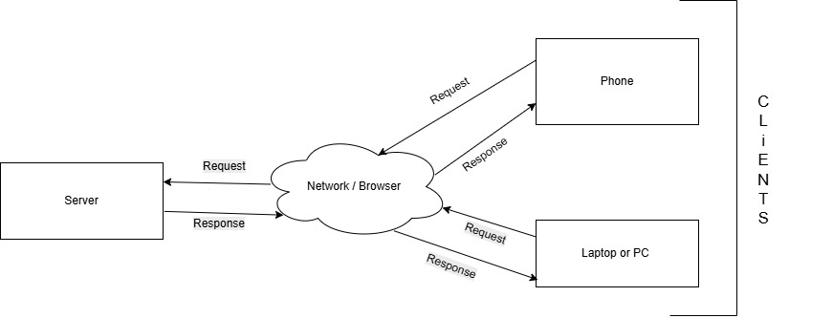

THEORY EXERCISE: Describe the roles of the client and server in web communication.
A) the client is the user’s device like phone, laptop and computer and it sends a request to get a webpage image, video, or any information from the internet.
Ex: When you type google.com, your browser (client) asks the server for that page.
The server is a powerful computer that stores websites and data and It receives the client’s request, processes it, and sends back the correct response (webpage, image, data, etc.).
Example: Google’s server sends the Google homepage to your browser.

5) Network layers on client and server.
A) The network layer on both the client and server is responsible for delivering data packets across the internet. It handles logical addressing (IP addresses), routing, and choosing the best path for data to travel. When a client sends a request, the network layer routes it through the internet to the server, and the server’s network layer sends the response back to the client.

LAB EXERCISE: Design a simple HTTP client-server communication in any language.

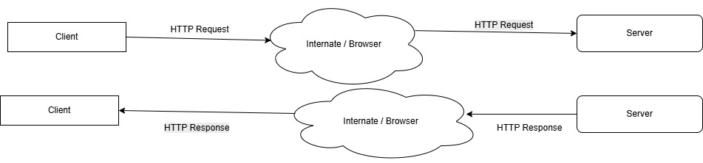

THEORY EXERCISE: Explain the function of the TCP/IP model and its layers.
A)

6) Client and Servers
A) A client is a program running on an end device that requests services, such as a web browser asking for a webpage.
A server is a program running on another end device that provides those services, like a web server delivering the webpage.
Together, client and server communicate over a network to exchange data and complete tasks.

THEORY EXERCISE: Explain Client Server Communication.
A) client-server communication is a model a client (like a browser or app) requests data or services from a server. The server processes the request and sends back a response using standard protocols like HTTP. It enables web browsing, email, and cloud services by allowing many users to access shared resources efficiently.

7) Types of internate connections.
A) there are 6 types of internate connections :
1. Digital Subscriber line (DSL)
2. Cable Internate
3. Fiber Optic
4. Satellite Internate
5. Wireless
6. Broadband over Power lines(BPL)

LAB EXERCISE: Research different types of internet connections (e.g., broadband, fiber, satellite) and list their pros and cons.
A) 1. Digital Subscriber Line (DSL)
Pros: uses existing telephone lines, so it's easy to set up.
More stable connection than dial-up.
Cons: Speed decreases if you live far from the provider.
Slower compared to cable and fiber.
2. Cable Internate
Pros: Faster speeds than DSL.
Widely available in cities and towns.
Cons: Speed can slow down when many people in the area use it.
More expensive than DSL.
3. Fiber Optic Internate
Pros: Very high speed and reliable performance.
Not affected by distance or electrical interference.
Cons: Limited availability in many places.
More expensive to install.
4. Satellite Internate
Pros: Available in remote and rural areas.
Easy to install where cables cannot reach.
Cons: High latency (slow response time).
Weather can interrupt the connection.
5. Wireless Internate
Pros: No cables needed; you can connect anywhere within range.
Easy to install and flexible for mobile devices.
Cons: Signal can be weak due to distance or obstacles.
Speed depends on network coverage and congestion.
6. Broadband over Power lines (BPL)
Pros: Uses existing electricity lines—no need for new cables.
Can provide internet in areas with no phone or cable lines.
Cons: Limited availability and still not widely used.
Can cause interference with radio signals.

THEORY EXERCISE: How does broadband differ from fiber-optic internet?
A) Broadband is a general term for high-speed internet that can use different types of cables like DSL, cable TV lines, or wireless signals.
Fiber-optic internet is a type of broadband that uses thin glass fibers and light signals, making it much faster, more reliable, and better for large data.
So, fiber is the newer and faster technology, while broadband includes all high-speed connections, not just fiber.

8) Protocols.
A) Protocols are rules and standards that computers follow to communicate with each other over a network.

LAB EXERCISE: Simulate HTTP and FTP requests using command line tools (e.g., curl).
A) Http
Https
FTP – file transfer protocol

THEORY EXERCISE: What are the differences between HTTP and HTTPS protocols?
A) HTTP is a protocol used for transferring data on the web, but it is not secure because the data is sent in plain text. HTTPS is the secure version that uses SSL/TLS encryption to protect data from hackers. HTTP uses http://, while HTTPS uses https:// and shows a lock symbol in the browser.
Overall, HTTPS is safer and preferred for login, banking, and payment websites.

9) Application Security.
A) Application security refers to security precautions used at the application level to prevent the theft or hijacking of data or code within the application.

LAB EXERCISE: Identify and explain three common application security vulnerabilities. Suggest possible solutions.
A) 1. SQL Injection
What it is: Hackers insert harmful code into input boxes (like login forms) to access or change the database.
Solution: Use input validation and prepared statements so the app only accepts safe input.
2. Cross-Site Scripting (XSS)
What it is: Attackers inject malicious scripts into web pages that run in the user’s browser.
Solution: Clean (sanitize) all user input and escape HTML characters before displaying it on pages.
3. Weak Passwords
What it is: Users use simple passwords like “12345,” which attackers can easily guess.
Solution: Use strong password rules, password hashing, and encourage multi-factor authentication (OTP, email code).

THEORY EXERCISE: What is the role of encryption in securing applications?
A) Encryption protects application data by converting it into unreadable code so only authorized users can access it. It helps secure sensitive information during storage and transmission. Even if attackers intercept the data, they cannot understand it without the correct key.

9) Software Applications and its Types.
A) Software Applications helps in the automation of the task based on the users input. It can perform single or multiple tasks at the same period of time.
Types of Application Software:
1. Application Software
2. System Software
3. Driver Software
4. Middleware
5. Programming Software

LAB EXERCISE: Identify and classify 5 applications you use daily as either system software or application software.
A)
- Application Software:
Used for daily tasks like messaging, browsing, or creating documents (e.g., WhatsApp, Chrome, MS Word).
- System Software:
Controls hardware and runs the computer, such as operating systems like Windows, Android, or iOS.
- Driver Software:
Helps the operating system communicate with hardware devices like printers, keyboard, or graphics card.
- Middleware:
Acts as a bridge between different applications to help them communicate (e.g., APIs, application servers).
- Programming Software:
Used by developers to write and test programs, such as VS Code, IntelliJ IDEA, and compilers.

THEORY EXERCISE: What is the difference between system software and application software?
A) System software manages the computer’s hardware and provides a platform for other programs to run, such as Windows, Linux, or Android. Application software is designed for users to perform specific tasks like browsing, writing documents, or playing music.
In short, system software runs the computer, while application software helps users do their work.

10) Software Architecture.
A) Software architecture is the blueprint of building software. It shows the
overall structure of the software, the collection of components in it, and how they interact with one another while hiding the implementation.

LAB EXERCISE: Design a basic three-tier software architecture diagram for a web application.
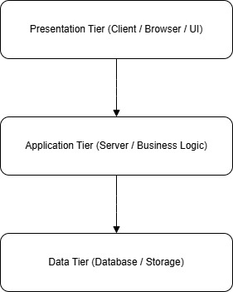
A)

THEORY EXERCISE: What is the significance of modularity in software architecture?
A) Modularity means breaking software into small, separate parts (modules).
It makes the system easier to understand, develop, and test.
It also helps in fixing or updating one module without affecting the whole software.

11) Layers in Software Architecture.
A) There are 5 layers in software architecture:
1. Presentation Layer
2. Application Layer
3. Business Layer
4. Persistence Layer
5. Database Layer

LAB EXERCISE: Create a case study on the functionality of the presentation, business logic, and data access layers of a given software system.
A) Case Study: Online Shopping Application
1. Presentation Layer: (UI Layer)
This is the part the user sees, such as webpages or mobile screens.
It shows product lists, login page, cart, and order details.
It sends user actions (like “Add to Cart”) to the business logic layer.
2. Business Logic Layer (Application Layer):
This layer processes all the rules and decisions of the system.
It checks login details, calculates the total bill, applies discount rules, and manages cart operations.
It acts as the “brain” between the UI and the database.
3. Data Access Layer: (Database Layer)
This layer communicates directly with the database.
It saves user details, products, orders, and payment data.
It receives queries from the business logic layer and returns the required data.

THEORY EXERCISE: Why are layers important in software architecture?
A) Layers are important in software architecture because they divide a big system into smaller, manageable parts.
Each layer has a specific job, so the system becomes easier to understand and develop.
If one layer changes, the others are not affected much. This makes the software more organized, secure, and easier to maintain.

12) Software Environments.
A) A software environment is the setup where programs run, including the operating system, software tools, and libraries.
It helps programs work correctly and interact with the computer.
Examples: Windows, Linux, and Python development environment.

LAB EXERCISE: Explore different types of software environments (development, testing, production). Set up a basic environment in a virtual machine.
A) 1. Explore Software environments:
Development Environment: Where you write and test your code (e.g., VS Code, Eclipse).
Testing Environment: Where you check if the code works correctly before release.
Production Environment: Where the final software runs for users.
2. Set up a Basic Environment in a Virtual Machine:
Install a virtual machine software like VirtualBox or VMware.
Create a new VM and install an OS (e.g., Ubuntu or Windows).
Install necessary tools: text editor or IDE (e.g., VS Code) for development.
Test by running a simple program (like “Hello World”) to ensure the environment works.

THEORY EXERCISE: Explain the importance of a development environment in software production.
A) A development environment is important because it provides the tools and space to write, test, and debug code safely.
It helps developers find and fix errors before releasing software.
This ensures the final program works correctly for users.

13) Source Code.
A) Source Code is the source of a computer program. It contains declarations, instructions, functions, loops and other statements, which act as instructions for the program on how to function.

LAB EXERCISE: Write and upload your first source code file to Github.
A) https://github.com/richa2193/SE_Workspace.git

THEORY EXERCISE: What is the difference between source code and machine code?
A) Source code is the human-readable instructions written by a programmer using a programming language.
Machine code is the low-level code made of 0s and 1s that the computer can directly execute.
Source code must be compiled or interpreted to become machine code for the computer to run it.

14) Github and Introduction.
A) GitHub is one of the most popular resources for developers to share code and work on projects together. It’s free, easy to use, and has become central in the movement toward open-source software.

LAB EXERCISE: Create a Github repository and document how to commit and push code changes.
A) https://github.com/richa2193/SE_Workspace.git

THEORY EXERCISE: Why is version control important in software development?
A) Version control is important because it saves changes to your code and keeps a history of updates.
It allows multiple developers to work together safely without overwriting each other's work.
It also helps recover previous versions if something goes wrong.
15) Student Account In Github.
A) A student account on GitHub gives free access to premium tools and features for learning and projects.
It helps students collaborate with others, and manage projects easily.
You can sign up using your school or college email to get these benefits.

LAB EXERCISE: Create a student account on Github and collaborate on a small project with a classmate.
A) https://github.com/richa2193/SE_Workspace.git

THEORY EXERCISE: What are the benefits of using Github for students?
A) GitHub helps students store and organize their code safely online.
It allows collaboration with classmates on projects and learning from others.
Students can show their work to teachers or employers and build a professional portfolio.

16) Types of Software.
A) 1. System Software: Helps the computer run, like Windows, Linux, or macOS.
2. Application Software: Programs for tasks, like MS Word, Excel, or web browsers.
3. Programming Software: Tools to write code, like Visual Studio, Eclipse, or Python IDEs.

LAB EXERCISE: Create a list of software you use regularly and classify them into the following categories: system, application, and utility software.
A) 1. System Software:
Windows 10 (operating system)
2. Application Software:
Google Chrome (web browser)
MS Word (document editing)
VLC Media Player (video player)
3. Utility Software:
CCleaner (system cleanup)
Windows Defender (antivirus)
WinRAR (file compression)

THEORY EXERCISE: What are the differences between open-source and proprietary software?
A) Open-source software is free to use, and anyone can view or modify its code (e.g., Linux, Firefox).
Proprietary software is owned by a company, requires a license, and the code is not shared (e.g., Windows, MS Office).
Open-source encourages collaboration, while proprietary focuses on controlled development and support.

17) Git and Github Training.
A) Git is a tool that helps you track changes in your code and work with different versions.
GitHub is an online platform where you can store code, collaborate, and share projects.
Learning them helps beginners manage projects safely and work with others easily.

LAB EXERCISE: Follow a GIT tutorial to practice cloning, branching, and merging repositories.
A) https://github.com/richa2193/SE_Workspace.git

THEORY EXERCISE: How does GIT improve collaboration in a software development team?
A) Git improves collaboration by allowing multiple developers to work on the same code without conflicts.
It keeps a history of changes, so everyone can see who did what and when.
It also makes it easy to merge updates and fix errors together as a team.

18) Application Software.
A) The most common type of software, application software is a computer software package that performs a specific function for a user, or in some cases, for another application.

LAB EXERCISE: Write a report on the various types of application software and how they improve productivity.
A) Application software includes programs like word processors, spreadsheets, and web browsers.
They help users perform tasks faster and more accurately, such as writing documents or analyzing data.
Using these tools improves productivity and efficiency in daily work and learning.

THEORY EXERCISE: What is the role of application software in businesses?
A) Application software helps businesses perform tasks efficiently, like managing documents, data, and communication.
It automates work, saving time and reducing errors.
Examples: MS Office, accounting software, and email clients.

19) Software Development Process.
A) The software development process is a step-by-step method to create software.
It includes planning, designing, coding, testing, and maintaining the software.
Following this process ensures the software is efficient, reliable, and meets user needs.

LAB EXERCISE: Create a flowchart representing the Software Development Life Cycle (SDLC).
A) SDLC is a step-by-step process used to develop, test, deploy, and maintain software systems.
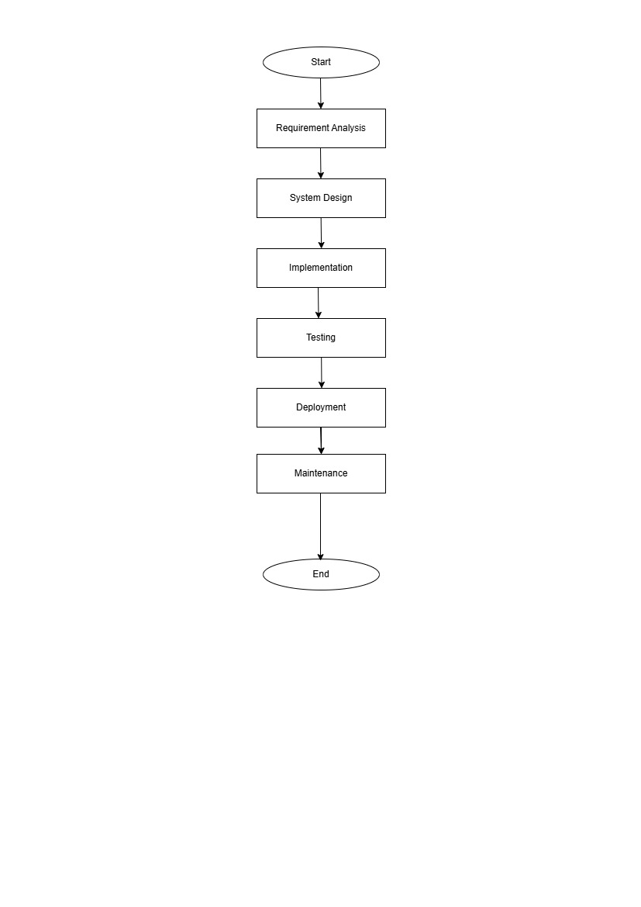

THEORY EXERCISE: What are the main stages of the software development process?
A) There are 6 main stages of the software development process.
1. Requirement Gathering
2. Analysis
3. Designing
4. Implementation
5. Testing
6. Maintenance

20) Software Requirement.
A) Software requirements are the needs and features that a software must have to work correctly.
They tell developers what the software should do and how it should behave.
Clear requirements help create software that meets user expectations.

LAB EXERCISE: Write a requirement specification for a simple library management system.
A) 1. Purpose:
To manage books, members, and borrowing activities efficiently in a library.
2. Functional Requirements:
Add, update, and delete books.
Register and manage library members.
Issue and return books with dates.
Search for books by title, author, or category.
3. Non-Functional Requirements:
The system should be easy to use.
Data should be stored securely.
The system should respond quickly to user actions.
4. Users:
Librarian (admin tasks)
Members (borrow and return books)

THEORY EXERCISE: Why is the requirement analysis phase critical in software development?
A) The requirement analysis phase is critical because it defines what the software should do before coding begins.
It helps developers understand user needs and avoid mistakes later.
Clear requirements save time, effort, and cost, ensuring the final software works correctly for users.

21) Software Analysis.
A) Software analysis is the process of studying user needs and system requirements before creating software.
It helps understand what the software should do and how it should work.
Good analysis ensures the software is useful, efficient, and meets user expectations.

LAB EXERCISE: Perform a functional analysis for an online shopping system.
A) 1. Functional Requirements:
User Registration/Login: Users can create accounts and log in.
Product Catalog: Display products with details like name, price, and description.
Shopping Cart: Add or remove products before checkout.
Payment System: Support online payments securely.
Order Tracking: Users can view the status of their orders.

THEORY EXERCISE: What is the role of software analysis in the development process?
A) Software analysis helps understand user needs and system requirements before coding.
It ensures developers know what the software should do and how it should work.
Good analysis prevents errors, saves time, and makes software more effective.

22) System Design.
A) System design is the process of planning how a software system will work and how its parts will interact.
It defines the structure, components, and data flow of the system.
Good system design helps make software organized, efficient, and easy to maintain.

LAB EXERCISE: Design a basic system architecture for a food delivery app.
A) Here’s a beginner-friendly system architecture for a Food Delivery App:
1. Users:
Customers (browse and order food)
Restaurants (manage menu and orders)
Delivery Personnel (accept and deliver orders)
2. Components:
Frontend: Mobile app or website interface for users.
Backend: Server to handle requests, process orders, and manage data.
Database: Stores user info, restaurant menus, orders, and delivery details.
Payment Gateway: Handles online payments securely.
3. Workflow:
Customer places an order → Backend processes it → Restaurant receives order → Delivery person delivers → Customer gets confirmation.
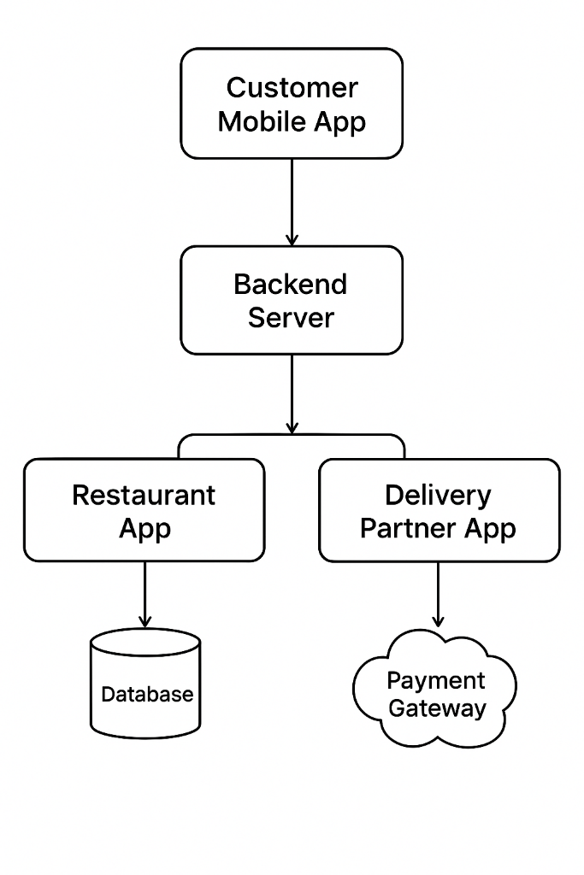

THEORY EXERCISE: What are the key elements of system design?
A) The key elements of system design include architecture, which defines how the system is structured.
It also includes data design and interface design, which show how data is stored and how users interact with the system.
Another important element is component design, which defines how different parts of the system work together.

23) Software Testing.
A) Software testing is the process of checking a program to find errors before it is released.
It ensures the software works correctly and meets user needs.
Testing helps improve quality, reliability, and user satisfaction.

LAB EXERCISE: Develop test cases for a simple calculator program.
A) Test Cases for Calculator Program
1. Addition Test Case
Input: 5 + 3
Expected Output: 8
2. Subtraction Test Case
Input: 10 – 4
Expected Output: 6
3. Multiplication Test Case
Input: 6 × 2
Expected Output: 12
4. Division Test Case
Input: 20 ÷ 5
Expected Output: 4
5. Division by Zero Test Case
Input: 10 ÷ 0
Expected Output: Error message (cannot divide by zero)
6. Negative Numbers Test Case
Input: –7 + 2
Expected Output: –5
7. Decimal Numbers Test Case
Input: 2.5 × 2
Expected Output: 5.0

THEORY EXERCISE: Why is software testing important?
A) Software testing is important because it helps find and fix errors before users face them.
It ensures the software works properly and meets requirements.
Testing improves quality, safety, and user satisfaction.

24) Maintenance.
A) Software maintenance is the process of updating and improving software after it is released.
It includes fixing bugs, adding new features, and improving performance.
Maintenance keeps the software useful, secure, and up to date.

LAB EXERCISE: Document a real-world case where a software application required critical maintenance.
A) 1. Corrective maintenance:
Real ex: A banking app crashed when users tried to transfer money during peak hours.
Developers fixed the software bug that caused the app to crash.
This maintenance was done to restore normal functioning of the app.
2. Adaptive maintenance:
Real ex: WhatsApp updated its app to support new Android and iOS versions.
The app was modified to run smoothly on new operating systems.
Changes were made to remain compatible with updated mobile devices.
3. Perfective maintenance:
Real ex: Amazon improved its shopping app to load faster and show better product recommendations.
The app’s performance and user experience were improved.
New features were added based on user feedback.

THEORY EXERCISE: What types of software maintenance are there?
A) 1. Corrective Maintenance – Fixing errors or bugs found after the software is released.
2. Adaptive Maintenance – Updating the software to work with new hardware, OS, or technologies.
3. Perfective Maintenance – Improving performance or adding new features based on user needs.
4. Preventive Maintenance – Making changes to prevent future problems and keep the software stable.

25) Development.
A) Software development is the process of creating programs and applications to solve problems.
It includes planning, coding, testing, and improving the software.

THEORY EXERCISE: What are the key differences between web and desktop applications?
A) Web applications run in a web browser and need an internet connection.
Desktop applications are installed on a computer and can work without the internet.

26) Web Application.
A) A web application is a program that runs in a web browser like Chrome or Firefox.
It can be used from anywhere with an internet connection.

THEORY EXERCISE: What are the advantages of using web applications over desktop applications?
A) Web applications can be used from any device with the internet, making them easy to access.
They don’t need installation, so they save storage and updates happen automatically.
They also allow easy collaboration because multiple users can access them at the same time.

27) Designing.
A) Designing means creating plans or ideas to make something look good and work well. It includes choosing colors, shapes, and layouts. Designers focus on making things attractive, easy to use, and clear for users.

THEORY EXERCISE: What role does UI/UX design play in application development?
A) UI/UX design creates an intuitive, visually appealing, and efficient user experience by balancing functionality and aesthetics. Good design improves usability, accessibility, and emotional involvement, resulting in increased user happiness and retention.

28) Mobile Application.
A) A mobile application is a software program designed to run on smartphones and tablets.
It helps users perform tasks like messaging, shopping, or learning easily on their phones.
Mobile apps are simple to use and can be downloaded from app stores.

THEORY EXERCISE: What are the differences between native and hybrid mobile apps?
A) Native apps are built specifically for one platform like Android or iOS, so they run faster and smoother.
Hybrid apps use web technologies and work on multiple platforms with a single code.
Native apps give better performance, while hybrid apps save time and cost.

29) Data Flow Diagram.
A)

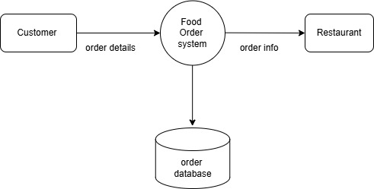

LAB EXERCISE: Create a DFD for a hospital management system.
A) level 0: Shows the whole system as ONE process.

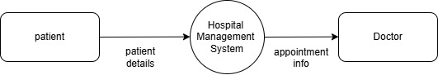

Level 1: Breaks the main system into smaller processes.

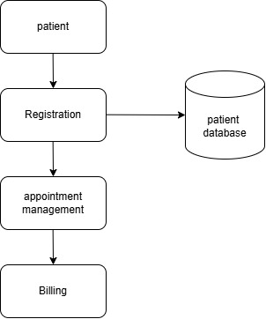

Level 2: Further breaks ONE Level-1 process into smaller steps.

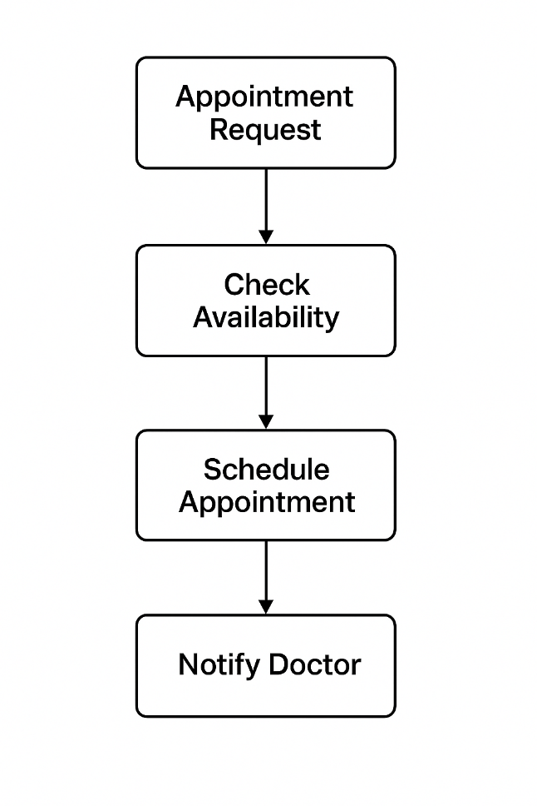

THEORY EXERCISE: What is the significance of DFDs in system analysis?
A) DFDs help understand how data moves within a system in a simple, visual way.
They show processes, data storage, inputs, and outputs clearly.
This helps analysts find problems, improve workflow, and design better systems.

30) Desktop Application.
A) A desktop application is software that runs directly on a computer, not on the internet.
It can work offline and usually has full access to the computer’s resources.
Examples: Microsoft Word, VLC Media Player, and Photoshop.

LAB EXERCISE: Build a simple desktop calculator application using a GUI library.
A) quit

THEORY EXERCISE: What are the pros and cons of desktop applications compared to web applications?
A) Pros: Desktop apps work offline, are faster, and can use full computer resources.
Cons: They need installation, updates are manual, and cannot be accessed from anywhere.
Web apps, in contrast, work online from any device but may be slower and need internet.

31) Flow Chart.
A) A flowchart is a diagram that shows the steps of a process using symbols and arrows.
It helps visualize how tasks, decisions, and actions are connected.
Flowcharts make it easier to understand, plan, and solve problems.

LAB EXERCISE: Draw a flowchart representing the logic of a basic online registration system.
A)
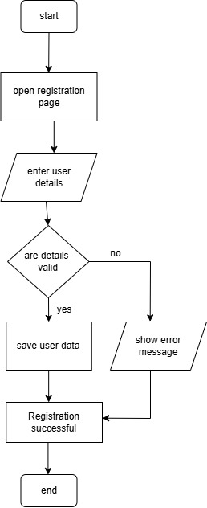

THEORY EXERCISE: How do flowcharts help in programming and system design?
A) Flowcharts help by showing the steps of a program or system visually, making it easier to understand.
They also help communicate ideas clearly to others.

